Daliah Aljutayli

**1.What is CLI (Command Line Interface)?**

**CLI** is the **interaction** with a **computer** program where the **user** enters a command (lines of text) to the shell which handles these commands.

**2.Create a directory with your name**.

**mkdir** Daliah (Make a directory) , I List the current directory content with **ls**



mkdir Daliah -> Make a directory named Daliah

ls ->List content of Current directory (root)

**3. Print the name of the current/working directory & 4. Move to new directory.**

pwd (**P**rint **W**orking **D**irectory)

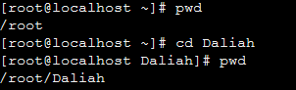

pwd -> display the current directory name (root)

cd Daliah->Change the directory to Daliah

pwd -> display the current path (Daliah)

**5.Create a text file with the name file.txt.**

cat to create a single text file and immediately Write it.

touch to create a single or multiple text files in sometime without entering any content.

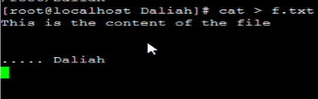

cat > f.txt -> Create a file txt

Write your content immediately

crtl + D -> to save file and close it

**6.Edit file.txt by putting the following: "Hello, this file created via Linux commands :)".**



vi file.txt -> Open the file.txt

Click insert key or I letter -> to start editing file.txt

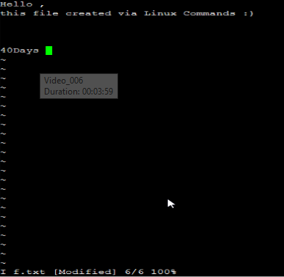

**7.Save and close the file.**

**Esc** Key the enter **:x** -> -> to Save and Close the file

**8.Print the file.txt content on the standard output.**

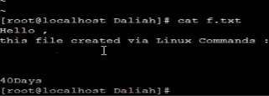

cat file.txt -> Display the content of file.txt